**Session 9 (unit 5): Operator Overloading**

|  |  |
| --- | --- |
| Roll No. A016 | Name: Varun Khadayate |
| Program: B-Tech (CSBS) | Division: SY |
| Batch: 1 | Date of Submission: 12-10-2020 |

1. **Use the concept of Operator overloading to overload ‘-’ operator to subtract two complex numbers.**

**ANS:**

**CODE:** #include<iostream>

using namespace std;

class comp

{

private:

float rl,ig;

public:

void rdata()

{

cout<<"Enter the real and imaginary values ::";

cin>>rl;

cin>>ig;

}

comp operator - (comp c2)

{

comp temp;

temp.rl = rl - c2.rl;

temp.ig = ig - c2.ig;

return temp;

}

void ddata()

{

if(ig < 0)

cout << "Output Complex number: "<< rl << ig << "i";

else

cout << "Output Complex number: " << rl << "+" << ig << "i";

}

};

int main()

{

comp c1, c2, result;

cout<<"Enter first complex number:\n";

c1.rdata();

cout<<"Enter second complex number:\n";

c2.rdata();

result = c1 - c2;

result.ddata();

return 0;

}

**OUTPUT:**

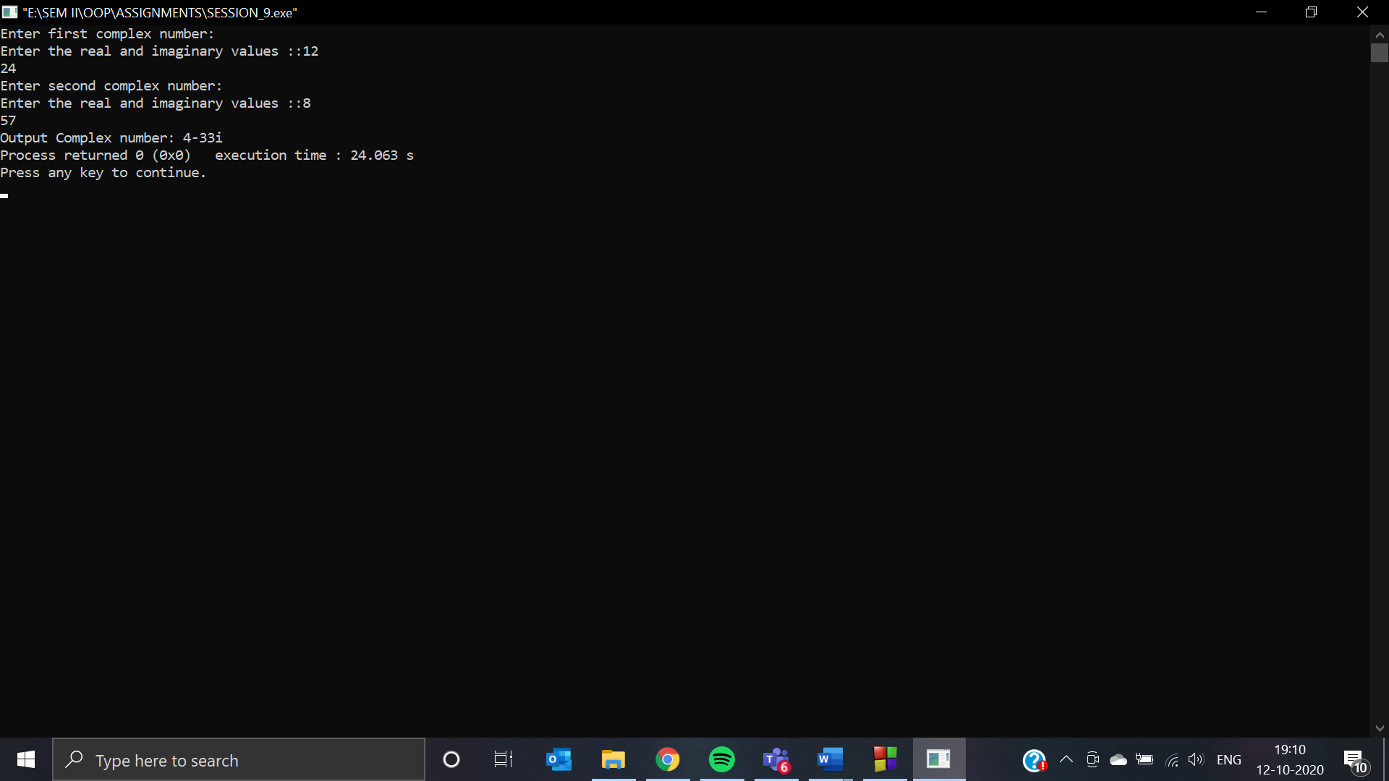

1. **Use the concept of Operator overloading to redefine the use of ‘++’ so that when this is encountered, then the value of variable increases by 100 and not by 1.**

**ANS:**

**CODE:** #include <iostream>

using namespace std;

class addval

{

private:

int num;

public:

addval()

{

cout<<"Enter the number::";

cin>>num;

}

void operator ++()

{

num = num+100;

}

void ddata()

{

cout<<"The value after incrementing it by 100 is: "<<num;

}

};

int main()

{

addval av;

++av;

av.ddata();

return 0;

}

**OUTPUT:**

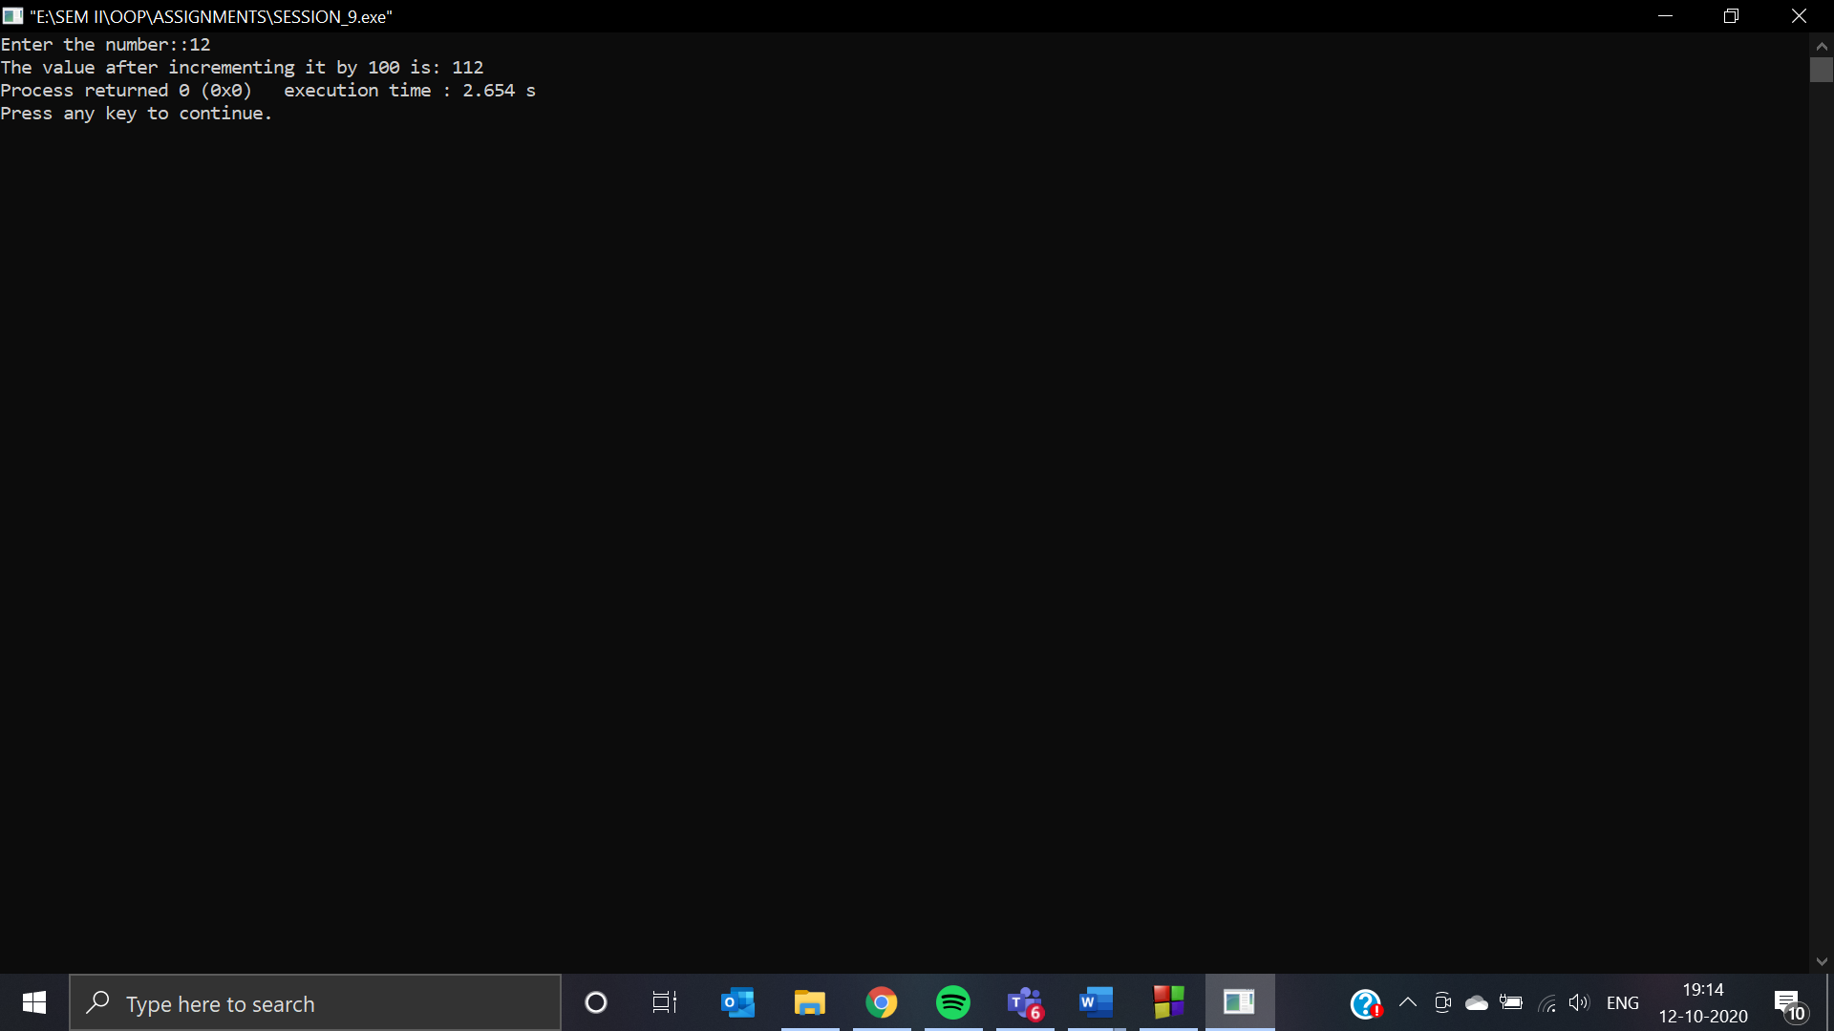

1. **WAP that accepts two objects of time class in hh:mm:ss format and is finally add the two times and display the addition result.**

**ANS:**

**CODE:** #include<iostream>

using namespace std;

class time

{

private:

int hr,mt,sc;

public:

void rdata()

{

cout<<"Enter the hour, minute and second values ::";

cin>>hr;

cin>>mt;

cin>>sc;

}

time operator + (time t2)

{

time temp;

temp.hr = hr + t2.hr;

temp.mt = mt + t2.mt;

temp.sc = sc + t2.sc;

return temp;

}

void ddata()

{

cout<<"The time after adding the given 2 timezones are:: "<<hr<<":"<<mt<<":"<<sc;

}

};

int main()

{

time t1, t2, result;

cout<<"Enter time for timezone 1:\n";

t1.rdata();

cout<<"Enter time for timezone 2:\n";

t2.rdata();

result = t1 + t2;

result.ddata();

return 0;

}

**OUTPUT:**

